- Purpose
Define the In-Process and End-of-Line tests and the engineering drawing notes that will trigger these tests for electric motor sub-assemblies and assemblies.

- Scope / Applicability
Who - Engineering, Process, Production, Quality
What - EWP drawings - parts and assemblies
When - Manufacturing – In Process and End of Line
Where - Gates Windsor

- Responsibility
Documentation - Design Engineering
Awareness / Compliance - Process, Manufacturing, Quality

- Related Documents
Governing Documents - None
Other Reference Documents - Test requirements from customer specifications

- Definitions / Abbreviations

  - ABBREVIATIONS

IP - In Process
EOL - End of Line (Assembly Line)
DMM - digital multimeter
BEMF - back- emf (electromotive force, measured in volts)
VDC - volts DC
DUT - device under test

  - DEFINITIONS

U, V, W terminals - the 3 terminals on the motor housing that organize and provide power to the 3 phase windings
Back-EMF - Voltage which is generated by the field from the permanent magnets moving in the vicinity of the stator coils

- Drawing Notes to Trigger In-Process and/or End-of-Line Electrical Tests

  - Foreword

This document defines requirements for EWP In-Process and End-of-Line Tests. It also specifies specific drawing notes. Example drawings notes are provided directly after the requirement.

  - Background

In-process and End-of-Line tests will be used to periodically qualify assemblies and sub assemblies before going to the next stage of production. The intent is to minimize adding value to parts that show early signs of downstream nonconformance.

  - Drawing Notes

Drawing notes are organized by test type, whether electrical or controller related.

TOC – IN-PROCESS AND END-OF-LINE TESTS
DRAWING NOTES ARE SHOWN ON SUB-ASSEMBLY OR FINAL ASSEMBLIES 3
1. DRAWING NOTES - ELECTRICAL IP TESTS 3
1.1. PHASE RESISTANCE 3
1.2. PHASE INDUCTANCE 3
1.3. BACK EMF – POWERED MOTOR 3
2. DRAWING NOTES – MOTOR AND CONTROLLER EOL TESTS 4
2.1. MOTOR RESPONSE TO CONTROLLER OUTPUT (NO LOAD / DRY TEST) 4
3. TEST AND EVALUATION PROCEDURES – INLINE ELECTRICAL TESTS 4
3.1. PHASE RESISTANCE 4
3.2. DIFFERENCE IN PHASE RESISTANCE 5
3.3. PHASE INDUCTANCE 5
3.4. DIFFERENCE IN PHASE INDUCTANCE 6
3.5. BACK EMF 6
BACK EMF – POWERED ROTOR / PWM CONTROLLED 6
EQUIPMEMENT 6
3.6. DIFFERENCE IN BACK EMF 7
4. TEST AND EVALUATION PROCEDURES – EOL MOTOR AND CONTROLLER TESTS 7
4.1. MOTOR RESPONSE CHECK 7

DRAWING NOTES

- DRAWING NOTES - ELECTRICAL IP TESTS

DRAWING NOTES SHALL BE SHOWN ON SUB-ASSEMBLY OR FINAL ASSEMBLIES

  - PHASE RESISTANCE

- Phase resistance shall be measured across terminal pairs UV, UW, and VW. Measurement is to be
made in milliohms, DMM precise to 2 or more decimal places.
- Phase resistances shall be noted on the sub-assembly drawing, example “Phase resistance 7.0 - 7.6 mΩ”.

- The differences in phase resistance between UV, UW, and VW shall be evaluated from the data.

  - PHASE INDUCTANCE

- PHASE inductance shall be measured across terminal pairs UV, UW, AND VW. Measurement is to be in micro-henry, LCR meter to be precise to 2 or more decimal places. Phase inductance shall be noted on the sub-assembly drawing, example “ 26.6 µH - 27.1 µH.”

- The differences in phase inductance between UV, UW, and VW shall be evaluated from the data, and shall be less than 1.5% of the value between each phase.

  - BACK EMF – POWERED MOTOR

- BACK EMF (BEMF), shall be measured across terminal pairs UV, UW, AND VW. Measurement is to be in VDC, precise to 2 or more decimal places. BEMF shall be specified in a table on the partial assembly drawing for various speeds.

- The differences in BEMF between UV, UW, and VW shall be evaluated from the data.

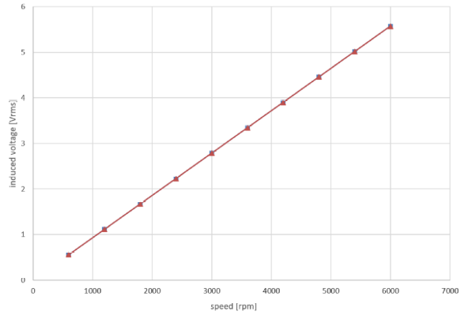

FIGURE 1: Typical BEMF Output

- DRAWING NOTES – MOTOR AND CONTROLLER EOL TESTS

  - MOTOR RESPONSE TO CONTROLLER OUTPUT (NO LOAD / DRY TEST)

- Motor and controller response (to a speed command), and current draw shall be verified at 3 input voltages and > 2 operating speeds and meet the requirements of the assembly drawing.

TEST AND EVALUATION PROCEDURES

- TEST AND EVALUATION PROCEDURES – INLINE ELECTRICAL TESTS

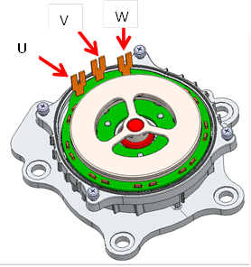

  - PHASE RESISTANCE

    - PURPOSE
Confirm acceptable phase resistance on sub-assembly

    - EQUIPMENT
DMM capable to measure mΩ and data recording computer

    - PROCEDURE
- Set DMM to measure resistance
- Zero the meter
- Set computer to begin test
- Connect and measure resistance across motor U & V terminals
- Hit button on screen for resistance recording of phases U and V
- When prompted, disconnect phase V and connect phase W
- Hit button on screen for resistance recording of phases U and W
- When prompted, disconnect phase U and connect phase V
- Hit button on screen for resistance recording of phases V and W
- Disconnect test leads from phase terminals
- Resistance measurement data must meet the value on the applicable assembly drawing
- Compliant samples may proceed to the next production station. Failures shall be routed into the reject bin for examination. Failures may be retested if results or procedure seems questionable

  - DIFFERENCE IN PHASE RESISTANCE

    - PURPOSE
Calculate balance of phase resistances between the UV, UW and VW phases

    - EQUIPMENT
Computer Labview software to calculate the difference between the measurements above

    - PROCEDURE
- Calculate the difference between steps 4 & 7 above
- Calculate the difference between steps 4 & 9 above
- Calculate the difference between steps 7 & 9 above

  - PHASE INDUCTANCE

    - PURPOSE
Confirm acceptable phase inductance

    - EQUIPMENT
Inductance meter capable of measuring µH and data recording computer
Non conductive workbench
No metallic objects within 50cm of the DUT

    - PROCEDURE
- Zero the LCR meter
- Set computer to begin test
- Connect and measure resistance across motor U & V terminals
- Hit button on screen for inductance recording of phases U and V
- When prompted, disconnect phase V and connect phase W
- Hit button on screen for inductance recording of phases U and W
- When prompted, disconnect phase U and connect phase V
- Hit button on screen for inductance recording of phases V and W
- Disconnect test leads from phase terminals
- Inductance measurement data must meet the value on the applicable assembly drawing
- Compliant samples may proceed to the next production station. Failures shall be routed into the reject bin for examination. Failures may be retested if results or procedure seems questionable

  - DIFFERENCE IN PHASE INDUCTANCE

    - PURPOSE
Calculate balance of phase inductance between the UV, UW and VW phases

    - EQUIPMENT
- Computer Labview software to calculate the difference between the measurements above

    - PROCEDURE
- Measurements versus the programmed values from drawing will be compared
- Inductance measurement data must meet the value on the applicable drawing
- Compliant samples may proceed to the next production station. Failures shall be routed into the reject bin for examination. Failures may be retested if results or procedure seems questionable.

  - BACK EMF

    - PURPOSE
Verify acceptable BEMF levels at defined speeds

BACK EMF – POWERED ROTOR / PWM CONTROLLED

EQUIPMEMENT
- Power supply capable of providing 20.0 ±0.1 VDC
- DMM precise to 2 or more decimal places

      - PROCEDURE
- Zero the meter
- Connect the 3 phase test leads from the controller to the housing sub-assembly
- Apply 12.5 VDC power and appropriate command signal to the test stand control board
- Begin the test on the computer by hitting button
- the computer will send a PWM command to the controller to spin the rotor at preprogrammed speeds (shown on drawing)
- Equipment will automatically measure the voltage generated across motor U, V & W terminals
- Equipment will automatically increase speed to next test step and repeat step 5 until test is completed
- BEMF measurement data must meet the value on the applicable assembly drawing
- Disconnect leads from the U, V and W phases
- BEMF data must meet the values on the applicable assembly drawing
- Compliant samples may proceed to the next production station. Failures shall be routed into the reject bin for QC examination. Failures may be retested if results or procedure seems questionable.

  - DIFFERENCE IN BACK EMF

    - PURPOSE
Verify the balance of BEMF measurements across the 3 phases

    - EQUIPMENT
- Computer will automatically calculate the differences between phases

- TEST AND EVALUATION PROCEDURES – EOL MOTOR AND CONTROLLER TESTS

  - MOTOR RESPONSE CHECK

      - PURPOSE
Check motor response to the software speed commanded by the controller board when the motor is not loaded

      - EQUIPMENT
- Power source capable of providing minimum 20.0 ±0.1 VDC
- PCB controller PWM input command
- PCB controller output PWM analyzer
- DMM capable of measuring voltage
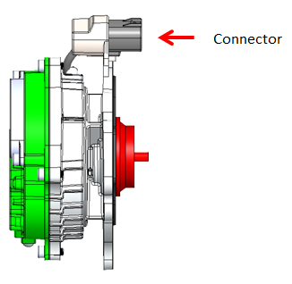

      - PROCEDURE
- Power the EWP with 13.5 VDC
- Start test by pushing start button on computer screen
- The computer will command the pump assembly to run at the lowest speed
- Measure the pump controller PWM output (amplitude and frequency, input voltage and current.
- Equipment will automatically increase speed to next test step and repeat step 4
- Measurement data must meet the values on the applicable assembly drawing
- Repeat steps 2-6 at 9.0VDC
- Repeat steps 2-6 at 16.0VDC
- Compliant samples proceed to the next production station. Failures shall be routed into the reject bin for QC examination. Failures may be retested if results or procedure seems questionable.

Document Revision History
Revision | Date | Revision Notes | Author
A | 9/28/2020 | Initial Release | George Spehar

